ISE 3700 - Design Project
Airport Surface Management

1. Your goal is to design a system to maximize departures from this airport on runway 36C (shown below). This includes specifying:
- The operational concept (describe the strategy your system increases departure
throughput, including a description of the actions available for the Airport Tower
Traffic Manager in order to increase departure throughput.
- The functioning of your algorithm to help manage the order of the departure queue to
runway 36C.
- The interface design.

2. Your system design should be illustrated using the airport show below, which is located at the site of the Dallas-Ft. Worth airport. You design can focus solely on flights departing north on runway 36C. For simplicity you can ignore departures using 36R and ignore the impact that arrivals would have on your design. (The blue lines in the figure below are runways. The black lines are taxiways to get to and from the runways and the airport terminal gates where the aircraft park.)
.
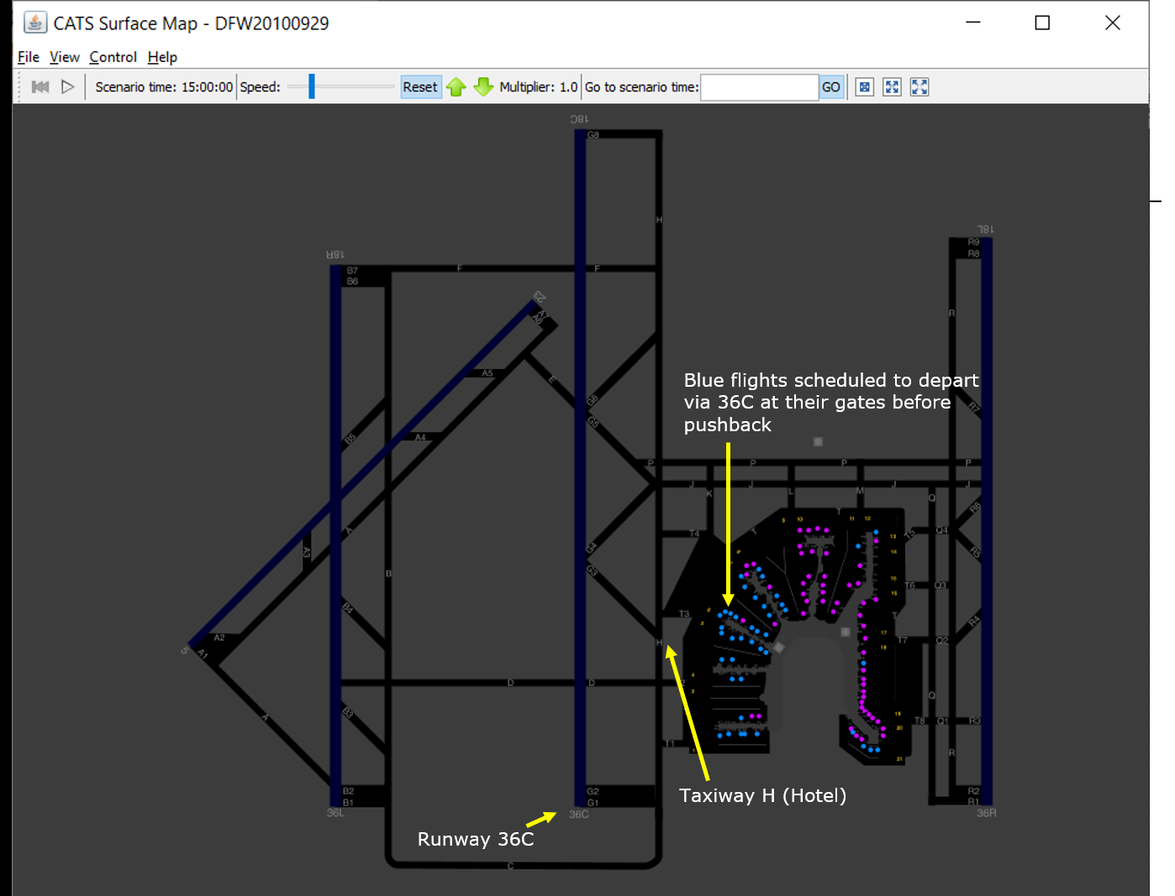

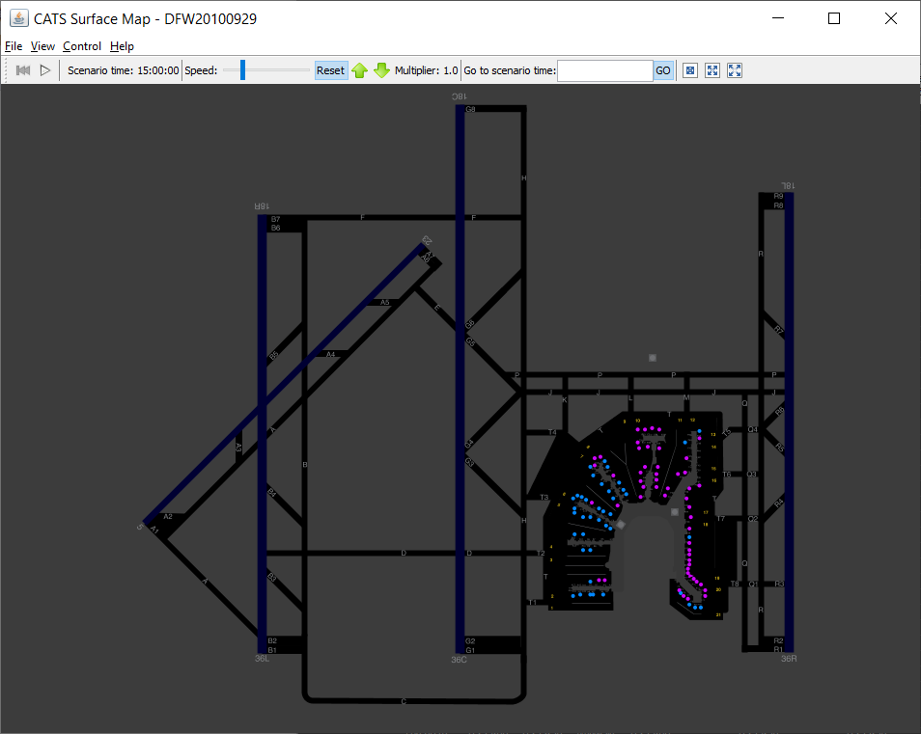

3. The diagram below shows the departure routes this airport when departing north.
- The two small vertical lines in the center of the graphic below are the departure runways (36C and 36R).
- Flights departing runway 36C must fly on the departure routes that are connected to that runway.
- Flights departing runway 36C must fly the departure routes that are connected to it.
- The departure fixes that define these departure routes are on the 60 mile range ring (such as NIKKY to the north).

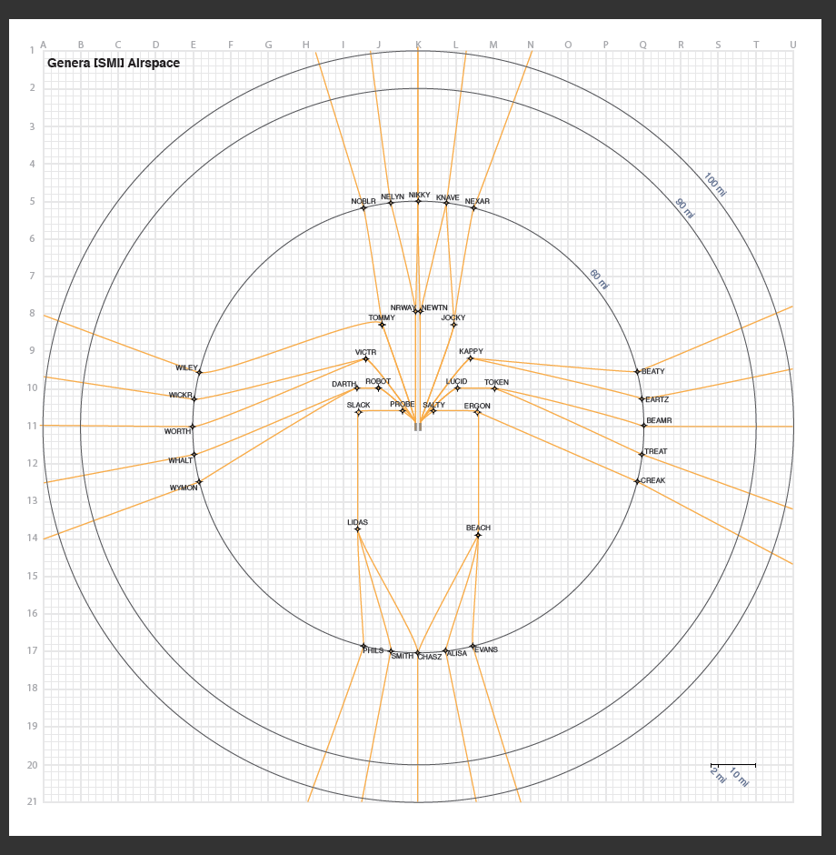

4. Flights departing from 36C must be spaced by a certain amount. (One flight has to wait a certain time after the last one has departed before it can take off.)
- Miles-In-Trail (MIT) refers to how far apart in distance two departing flights must be spaced (i.e., the second one can depart when the aircraft in front of it has flown a certain number of miles from the airport).
- If one flight is lined up to depart right after another aircraft and they are filed to use different departure fixes and there is no MIT restriction for either fix, then the second flight has to wait 60 seconds after the lead aircraft departs before it can take off. (This is a slight simplification for this assignment. The actual rules are contained in Appendix A for your general knowledge.) For example, if the first aircraft is departing via NOBLR and the second is departing via NELYN and there is no MIT restriction for NOBLR or NELYN, then the second flight can depart 60 seconds after the first.
- If one flight is lined up to depart right after another and they are filed to the same departure fix and there is no MIT restriction for either fix, then the second flight has to wait 75 seconds after the lead aircraft departs before it can take off. (This is a slight simplification for this assignment. Again see Appendix A. for the actual rules.) For example, if the first aircraft is departing via NOBLR and the second also is departing via NOBLR and there is no MIT restriction for NOBLR, then the second flight can depart 75 seconds after the first.
- If a fix has a MIT restriction, then the time between successive departures for flights filed to that fix is specified in the table below.
  - For instance, if there is a 12 MIT restriction for departures via WILEY, if the first aircraft is departing via WILEY and the second also is departing via WILEY, then the second flight can depart 180 seconds after the first. Thus, there would be a reduction in departure throughput.
  - As another example, if the flights lined up to depart are filed so the first is a departure via WILEY, the second via NOBLR, the third via SMITH, and the fourth via WILEY, they can each depart 60 seconds after the preceding flight because the second WILEY departure has 2 flights departing via other fixes in between (splitters), which means there are 180 seconds between the departures of the two flights departing WILEY.

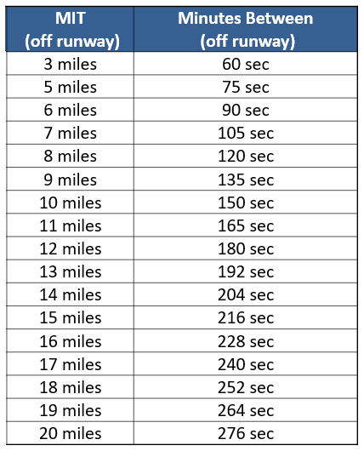

5. The job of the Airport Tower Traffic Manager is to line up the flights in the departure queue in order to maximize departure throughput. This means that she has to re-order the flights in the departure queue based on any MIT restrictions that may be in effect. Alternatively, she can reroute aircraft, changing their departure fixes, thus improving the line-up in the departure queue.

6. For the example that you use for this project, assume the weather as shown in the following two figures results in the following information being communicated at 1750Z and is used to adjust the departure sequence starting at 1800Z.
- A 12 MIT restriction for flights departing via WILEY from 1800-1835Z. This is communicated to the Airport Tower Traffic Manager in a display that is not part of the system you are designing.
- Closure of WICKR from 1800-1835Z (meaning that no flights can depart via that fix). Those flights are therefore held at their gates for 30 minutes.
- There are no other MIT restrictions.

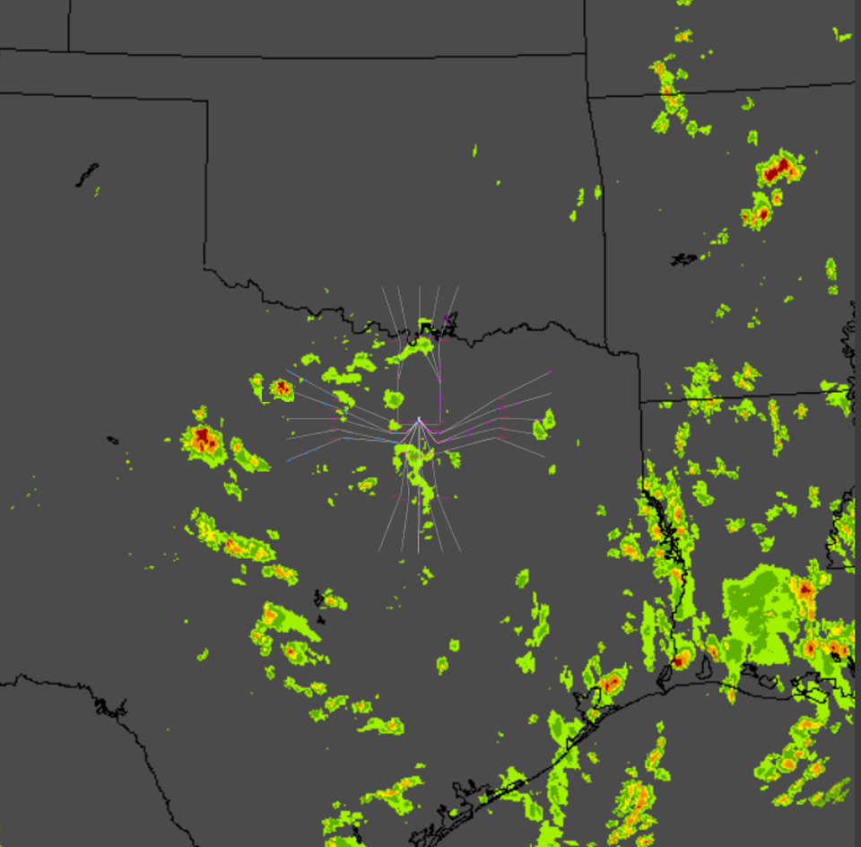
Actual Weather at 1800Z


Forecast weather in 30 minutes (1830Z)

6. Assume the Airport Tower Traffic Manager (working for the FAA) has to use the software to make any desired reroutes (changing the departure fix/route that a flight is going to fly) manually, one flight at a time (i.e., she can’t ask the software to change all flights filed to depart via NOBLR to be changed to depart via NELYN for a particular time range).
7. Assume she can reroute a flight at most one departure fix to its right or one departure fix to its left.
8. Assume the Airport Tower Traffic Manager can change the order of the flights and therefore the
sequence of departure fixes associated with those flights in the departure queue by swapping the order of the flights in the departure queue and holding them at their gates an appropriate amount of time so that they arrive at the departure queue in the new order. (Note that we are simplifying things by assuming a deterministic model for the time of the actual pushback from the gate for a flight and for its taxi time to get in the departure queue.)
7. Assume the current time is 1800Z.
8. Assume that you can’t reroute a flight that is within 10 minutes of its Target OFF time. Also assume that you can’t change the order of the flights within 10 minutes of their Target OFF time.
9. Assume that, when swapping the order of flights in the departure queue, you can move a flight 5 minutes earlier in terms of its Target OFF time or 5 minutes later in terms of its Target OFF time.
10. For simplicity, assume that, when possible, it is preferable to change the order of pushback (Target OUT) rather than reroute flights, because rerouting adds extra time in flight and therefore extra fuel burn.
11. Assume the following as the current plan for the departure queue. Flights departing
the soonest are at the bottom of the list. You only have to show how your system works for this set of flights.

Target Dep
ACID OFF(Z) Fix
AAL2561 1839:30 WILEY
DAL4703 1838:15 WILEY
DAL2684 1837 WILEY
AAL3441 1836 CHASZ
AAL0639 1835 WILEY
EGF1218 1833 NELYN
DAL2777 1832 WILEY
AAL9355 1830 SMITH
AAL7665 1829 WILEY
EGF9310 1827 CHASZ
AAL7665 1826 WILEY
DAL9416 1824 PHILS
AAL8912 1823 WILEY
DAL5519 1821 NELYN
EGF0862 1820 WILEY
SKW3013 1818 NICKY
EGF1050 1817 WILEY
AAL1180 1815 NELYN
KAL0043 1814 WILEY
AAL7799 1812 WORTH
DAL5919 1811 WILEY
AAL3074 1810 WORTH
EGF0512 1809 CHASZ
AAL3074 1808 SMITH
AAL8365 1807 WILEY
DAL2964 1805 WHALT
AAL2435 1804 WILEY
AAL3546 1802 WORTH
DAL5917 1801 WILEY
DAL2306 1800 PHILS

Using these sample data:

1. Learn the domain as defined above.

Prepare an 8 minute presentation in which you:
- Describe the functionality underlying your system design and the supporting design rationale. (In essence, you are describing the requirements for someone to write the code to support the functions that you are proposing.)
- Illustrate your interface design with a storyboard that shows the sequence of screens that the Airport Tower Traffic Manager would see if using your system to adjust the planned sequence show above in order to maximize throughput (minimize departure delay). Explain why you designed it this way support usability and usefulness.
All of the students in the group should participate in this presentation.

Your presentation will be evaluated in terms of clarity and the effectiveness of your presentation styles.

Your design will be evaluated in terms of:
- Usefulness
- Usability

Appendix A. Converting MIT at a Departure Fix to MIT Off the Runway
(Note: This is for information only. We are used a simplified set of rules
for this project as described above in the assignment.)

